Re-using your Casual Payroll Submission Spreadsheet from a previous month

The problem
At the Focus Programme workshops, a number of you reported that sometimes your submission for the current month is very similar to that for the previous month. You therefore find it frustrating that you have to re-enter data the majority of which is exactly the same.

The workaround
Subject to the warnings below, you can take a copy of a previous month’s spreadsheet, and edit it so that it contains this month’s data (most obviously, the dates will have to change).
- You should always use the most up-to-date version of the Casual Payroll Submission Spreadsheet. Before using a copy of a previous month’s spreadsheet and amending it, you should check that the version you have is the most up-to-date one by comparing it with the one on the website, which can be found on the Casual Payment Process page. The spreadsheet has a coloured banner which states when it valid from.
- All data needs to be checked, in order to avoid the problems associated with duplicate lines, which take up a lot of time to resolve. In particular, please ensure that all the Week/Period Ending values refer to the month you are submitting for, rather than the previous month. Other data, such as hours worked and pay code, should also be reviewed and amended as necessary.
We understand that this workaround may not help everyone, but sufficient numbers of you mentioned it that we believe it will be of benefit to some of you.

Blank lines in a Casual Payroll Submission Spreadsheet

The problem
At the Focus Programme workshops, some of you reported that you had effectively adopted the approach outlined in point 1 above – that is, you were submitting a previous month’s spreadsheet, and amending the data as necessary.
However, if one of the workers for last month didn’t work this month, you expressed concern that you could not submit a spreadsheet with a blank line in it. For example, suppose that you submitted the following for August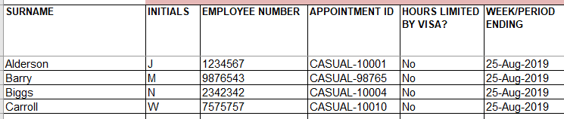
And for September, you wanted to submit the following data
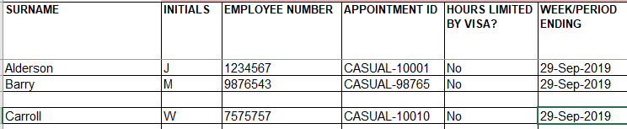
The concern was that due to restrictions in the sheet, it was not possible to close up the blank line, but you were concerned that any lines after the blank line would not be processed.

The workaround
We can confirm that it is OK to submit a spreadsheet with a totally blank line in it. The blank line will be ignored, and the lines after it will be processed.

3. You may not have access to CoreHR

The problem
At the Focus Programme workshops, some attendees, notably those working in Finance teams, reported that they wanted to have access to CoreHR – but did not have it.

The workaround
Access to CoreHR would enable these staff to identify fields such as Employee Number, Appointment ID and Cost Allocation. If you believe staff in your department/faculty would benefit from this, you can direct them towards the Training and Access Checklist page to request ‘Personnel Administrator (Read only)’ access. It would also be helpful to direct them towards sections 3-5 of the QRG NAV1 - Accessing & navigating CoreHR.

4. Using Excel’s ‘Fill’ feature to copy rows

The problem
The default behaviour of ‘Fill’ in Excel is to increment fields that look like numbers, or which have a numerical component. This isn’t helpful if you want to copy a set of fields. For example, if you have a row like this:
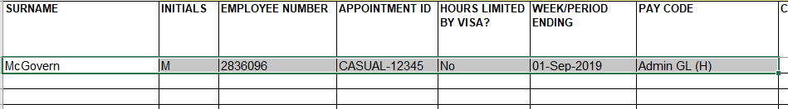
And you left-click on the ‘fill handle’ (the small square at the bottom right corner of the Pay Code cell in the diagram), and then drag it downwards, some of the fields will copy, but the Employee Number, Appointment ID and Week/Period Ending fields will all automatically increment, which is not what you want, like this:
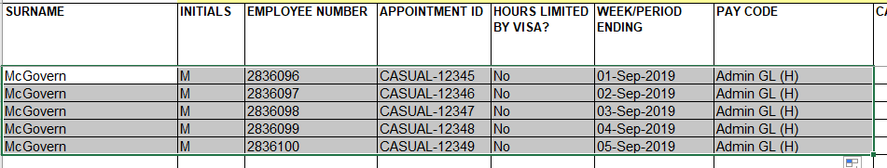

The workaround
Instead of left-clicking on the fill handle, right-click on it and drag it down. When you release the mouse button, a context menu will appear that looks like this:
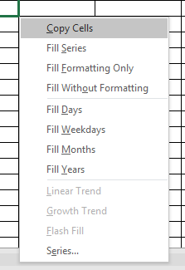
Select the ‘Copy Cells’ option, and the result will look like this:
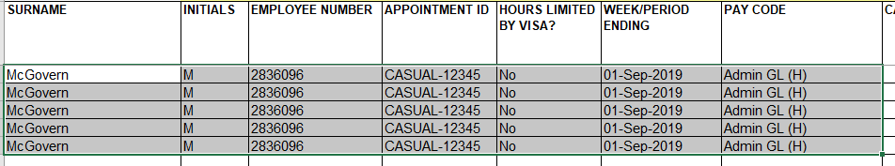
Please note that you will have to amend the Week/Period Ending values in order to reflect the correct dates worked.

