What’s new in CoreHR
Phase 2.1
Contents
1. Overview 2
2. Navigation 2
3. New features 3
3.1 Formatting Advert text 3
3.2 View Staff Request from vacancy 3
3.3 Recent applicant activity 3
3.4 Vacancy Overview – applicant statuses (including incomplete applications) 3
3.5 Applicant status history 3
3.6 See emails sent to applicants 4
3.7 Interviews: view your schedule and the vacancies for which you are a member of the interview panel 4
3.8 Download centre (accessing generated correspondence) 4
3.9 Notifications 4
4. Changes 4
4.1 Record your vacancy comments 4
4.2 Questionnaire preview not available in the Portal 4
4.3 Identifying advert as authorised 5
4.4 No longer need to submit web applicants 5
4.5 Identifying priority candidates 5
4.6 ‘From’ email address 5
4.7 Recording successful candidates 5
4.8 Prefix for vacancy events 5
4.9 Recruitment read-only access 5
5. Exceptions 5
5.1 Manual applications 6
5.2 Unsubmitting applications 6
5.3 Offering job offer to standby candidate 6

Overview

Document purpose

This document has been created for CoreHR users and it highlights the system changes introduced in phase 2.1 of the CoreHR Upgrade project. It does not include system guidance; please refer to our new training/support materials, here.

Recruitment has moved to the Portal

Departmental recruitment administrators will now access and manage vacancies and applications from the Portal area of CoreHR. The Portal area of the system is where Staff Requests and HR Self-Service are already accessed from.

The following existing modules remain in the Back Office:

- Personnel – used to record new starters, staff changes and leavers.
- Time and Attendance* – used to record sickness and other absences.
- Training* – used to manage training bookings.

NB A limited number of tasks will remain in the Back Office; see ‘Exceptions’ for details.

*used by a small number of teams/departments

Navigation

2.1 Dashboards

Access the following dashboards from the ‘corehr’ menu (depending on level of access).

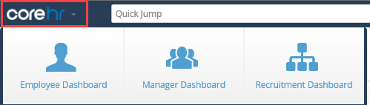

2.2 New look and feel: improved navigation

Recruitment navigation in the Portal is now more intuitive than in the Back Office. We have also removed and renamed, where possible, menus and fields that are not in use.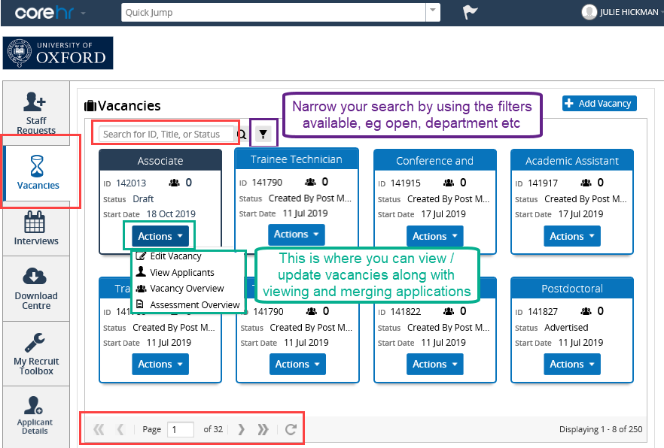
2.3 Date format

The Back Office has a very specific way of typing in dates (01jan20), in the Portal you can key in dates in a number of different ways, eg 010120, 01/01/20, 01.01.20, 01ja20.

2.4 Drop-down menus (type in text)

For faster selection simply begin typing the first characters of a value.

New features

3.1 Formatting Advert text

New formatting features include bold, italics and numbered/bulleted lists. This works differently to ‘Word’, and you cannot copy text formatted in Word into CoreHR.

A new Adverts style guide will be published prior to go-live, on the HR Support website. All departments will be required to follow this guidance.

Text limit: all adverts must now be under 3,500 characters (equivalent to about 500 words). Adverts above this character limit will be rejected. This word limit applies to most external job boards and helps create consistency across the University.

New spellchecker feature: you no longer need to create the advert in ‘Word’ first.

3.2 View Staff Request from vacancy

From the vacancy record you are able to see the approved Staff Request.

3.3 Recent applicant activity

You can now see a list of applications submitted in the last week, for your vacancies.

3.4 Vacancy Overview – applicant statuses (including incomplete applications)

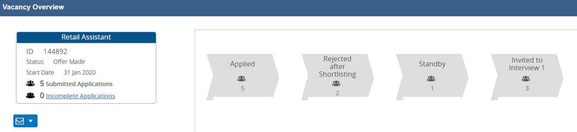

Above is an example of the new Vacancy Overview screen, which shows the number of applicants who reached each stage of the recruitment process, for a particular vacancy.
You can also see a list of applicants who haven’t yet submitted their application. This is visible during each stage of the recruitment process.

3.5 Applicant status history

The below example shows an applicant’s status throughout the selection process.

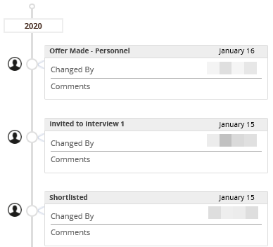

3.6 See emails sent to applicants

You can now see emails sent from CoreHR to individual applicants.

Please note, if an applicant has applied for multiple vacancies, departmental users will be able to see sent emails from the Portal relating to all vacancies they have applied for, irrespective of which department it was sent from. Historical emails sent via the Back Office will not be transferred/visible in the Portal.

We appreciate this doesn’t follow our usual departmental security model in the system, however this does comply with GDPR regulations.

3.7 Interviews: view your schedule and the vacancies for which you are a member of the interview panel

If you are marked as a member of an interview panel in the system, and have recruitment (administrator or read-only) access, you will see the relevant upcoming scheduled interviews in CoreHR. You can also see at a glance the vacancies for which you have been recorded as a member of the interview panel.

3.8 Download centre (accessing generated correspondence)

Recruitment documents created in CoreHR are created against the applicant’s record and accessed via the Download Centre. Please note, the system overwrites documents of the same type, so they must be saved locally before generating the next one.

3.9 Notifications

You should see a notification each time a document is created in the system, eg University Card form. However, these can be slow to appear, and we suggest you go to the Download Centre and refresh your screen until your document appears.

Changes

4.1 Record your vacancy comments

You can use this optional field to record information that you would find useful in your department. Please note this information does not appear in any of the HRIS reports.

4.2 Questionnaire preview not available in the Portal

We advise that you pay close attention to the Current Questions menu to see which questions are included and in which order, as you won’t be able to preview this.

4.3 Identifying advert as authorised

When a vacancy advert has been authorised by the Adverts team, it is not possible to identify this in the Portal. You will still receive an email to confirm authorisation.

4.4 No longer need to submit web applicants

Applicants will automatically appear against the vacancy record as soon as the application has been submitted by the applicant.

4.5 Identifying priority candidates

The Applicant Details Report feature is not available in the Portal (ie button on the Applicant Status screen in the Back Office). Priority candidates should be identified (for those that completed the short/ full application) using the merged PDF pack (still using Ctrl + F). For applicants who have competed the application with the inbuilt supporting statement, please continue to refer to the PERDEP47 private questions report.

4.6 ‘From’ email address

You can no longer enter the ‘From’ email address when sending emails. All emails will be sent from a new ‘no reply’ central account: HRIS.MAILRETURN@IT.OX.AC.UK. If applicants accidently reply to the email, they will receive an automatic reply.

This cannot be changed, and as a result all email templates will be updated to include:

‘Please do not reply to this email, the mailbox it has been sent from is not monitored.’

We have updated some email templates to prompt departments to enter their own email address in the body text. You will need to update each email sent in that batch.

4.7 Recording successful candidates

The Applicant Offer Wizard is now only available when you use the applicant status ‘Offer Made – Personnel’ (previously you could record the offer/acceptance via the wizard).

4.8 Prefix for vacancy events

Vacancy Events that should be completed at the end of the selection process now have a prefix of ‘~’; previously they had a prefix of ‘X’.

4.9 Recruitment read-only access

Whilst most of the access is on read-only basis for ‘recruitment administrator read-only’ users, it is technically possible for them to create and edit interview schedules. This is an unavoidable feature of settings in the Portal. Read-only users are informed via relevant training materials that they should not use this functionality.

Exceptions

The processes below cannot be done in the Portal and will continue in the Back Office:

5.1 Manual applications
Where, for whatever reason an applicant is unable to apply online, please refer to the current QRG.

5.2 Unsubmitting applications
Where an applicant requests their application to be unsubmitted, continue to contact HRIS Support Centre for guidance.

5.3 Offering job offer to standby candidate
When you have recorded an offer to an applicant, the applicant is not automatically unlinked from the planned appointment if the offer is declined.

5.4 Adding Question Categories (added June 2020)
This only applies to vacancies advertised on the Internal Jobs Board, which require additional question categories.

